WEEK4 Spring REST using Spring Boot 3
EX.1Create a Spring Web Project using Maven
package com.cognizant.springlearn;

import org.slf4j.Logger;
import org.slf4j.LoggerFactory;
import org.springframework.boot.SpringApplication;
import org.springframework.boot.autoconfigure.SpringBootApplication;
@SpringBootApplication
public class SpringLearnApplication {

private static final Logger LOGGER = LoggerFactory.getLogger(SpringLearnApplication.class);
public static void main(String[] args) {
LOGGER.info("START");
SpringApplication.run(SpringLearnApplication.class, args);
LOGGER.info("END");
}
}

server.port=9191

logging.level.org.springframework=INFO
logging.level.com.cognizant.springlearn=DEBUG
logging.pattern.console=%d{yyMMdd}|%d{HH:mm:ss.SSS}|%-20.20thread|%5p|%-25.25logger{25}|%25M|%m%n

Output:
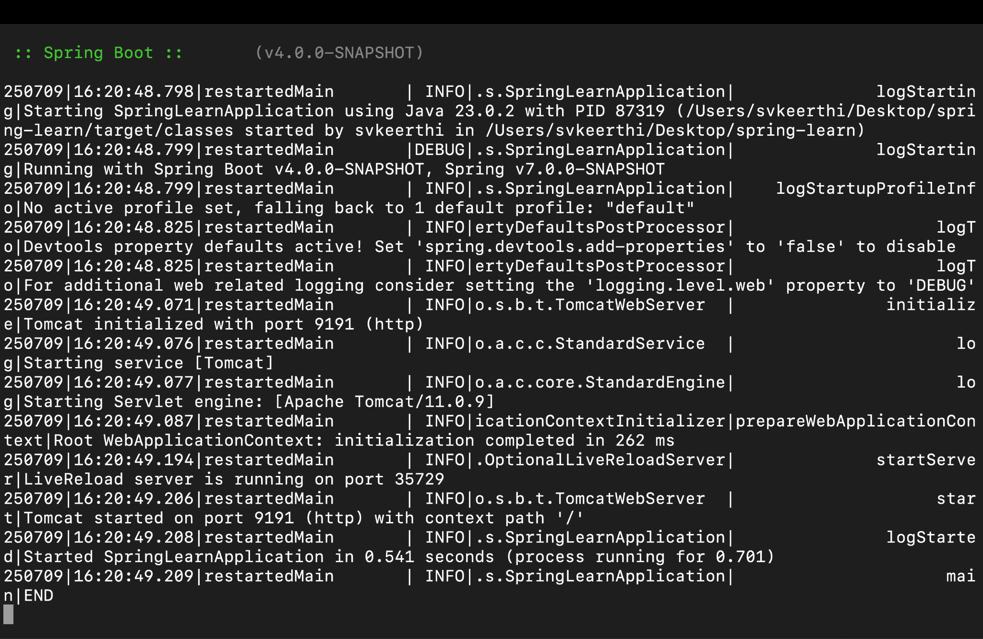
EX.2 Spring Core – Load Country from Spring Configuration XML

<bean id="dateFormat" class="java.text.SimpleDateFormat">
<constructor-arg value="dd/MM/yyyy" />
</bean>

public static void displayDate() {
LOGGER.info("START");
ApplicationContext context = new ClassPathXmlApplicationContext("date-format.xml");
SimpleDateFormat format = context.getBean("dateFormat", SimpleDateFormat.class);

try {
Date date = format.parse("31/12/2018");
LOGGER.debug("Parsed Date: {}", date);
} catch (Exception e) {
LOGGER.error("Error parsing date", e);
}
LOGGER.info("END");
}

Output:
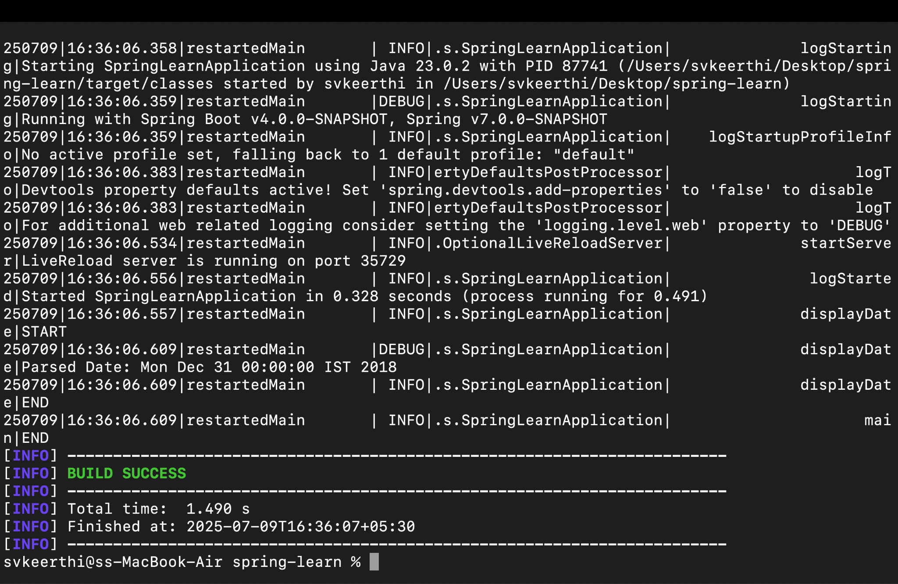

EX.3 Hello World RESTful Web Service
package com.cognizant.springlearn.controller;

import org.slf4j.Logger;
import org.slf4j.LoggerFactory;
import org.springframework.web.bind.annotation.GetMapping;
import org.springframework.web.bind.annotation.RestController;

@RestController
public class HelloController {

private static final Logger LOGGER = LoggerFactory.getLogger(HelloController.class);

@GetMapping("/hello")
public String sayHello() {
LOGGER.info("START");
String message = "Hello World!!";
LOGGER.info("END");
return message;
}
}
Output:
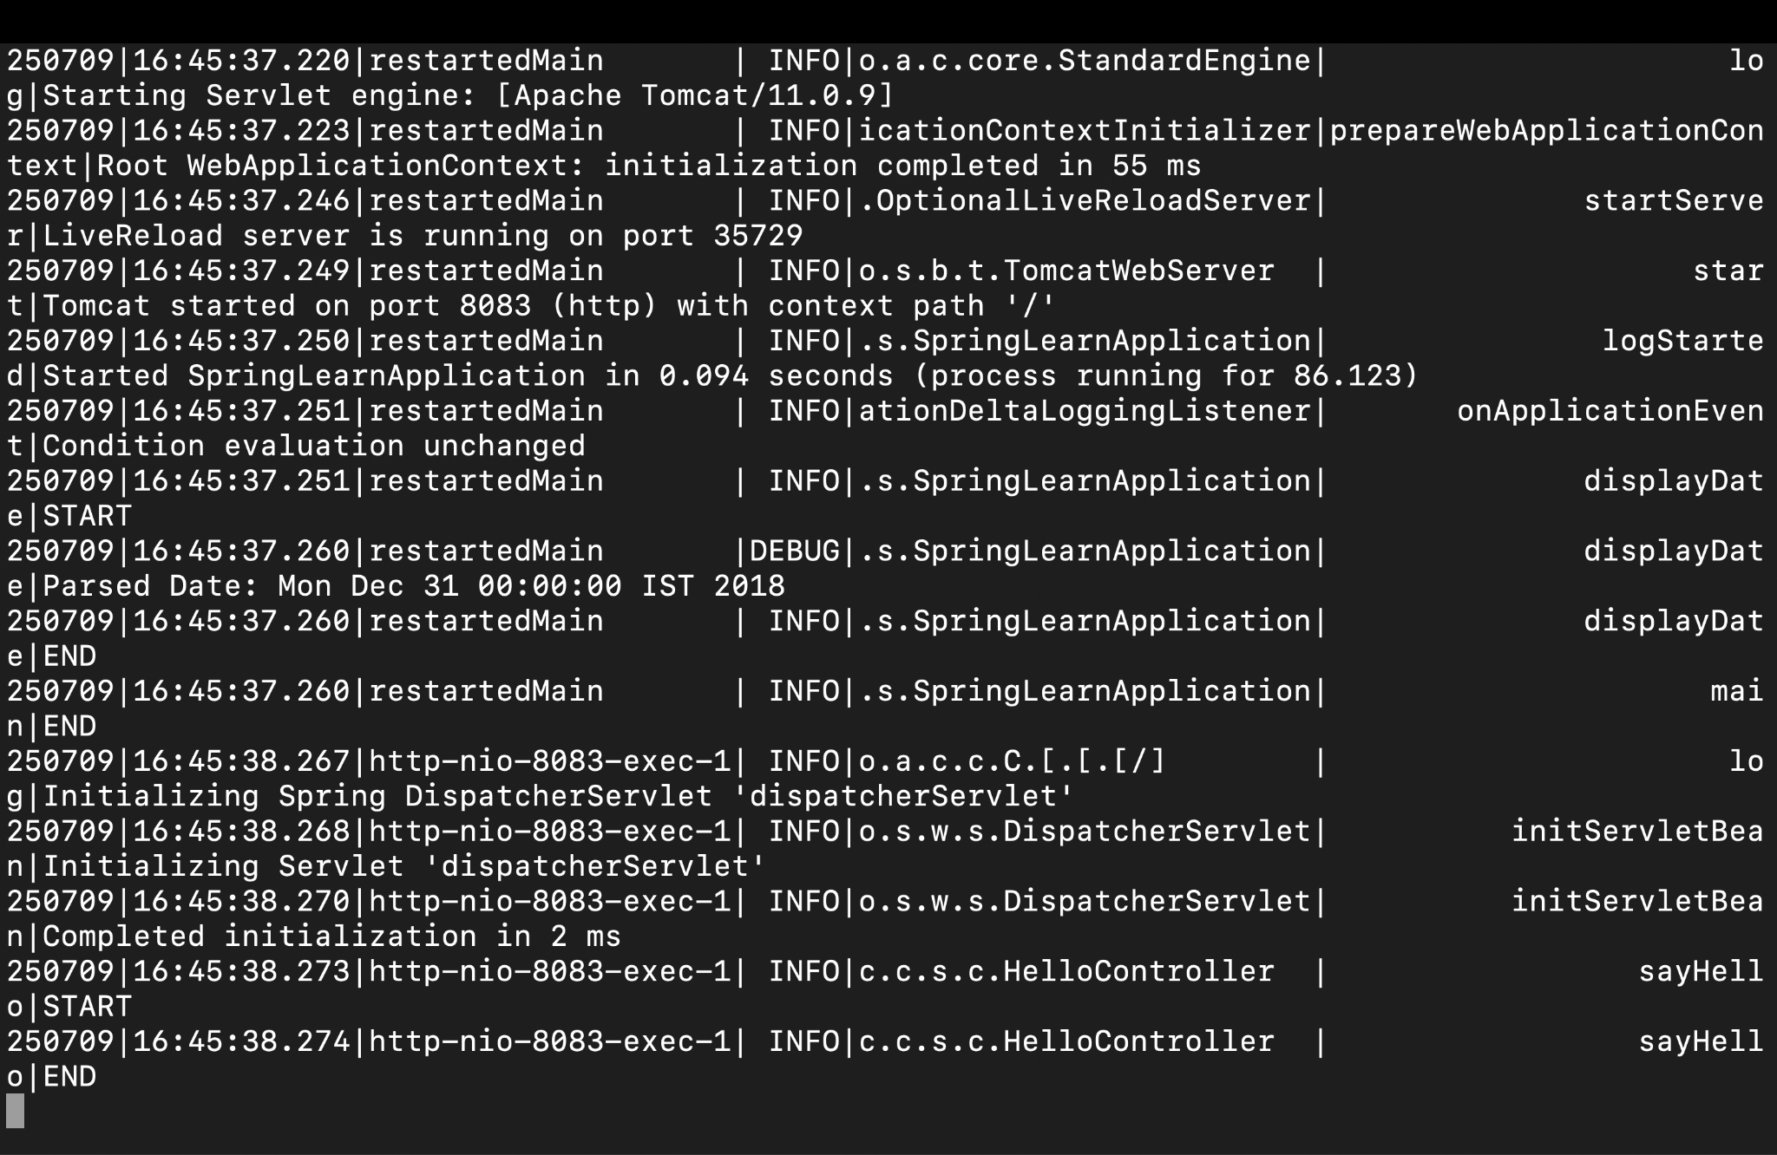

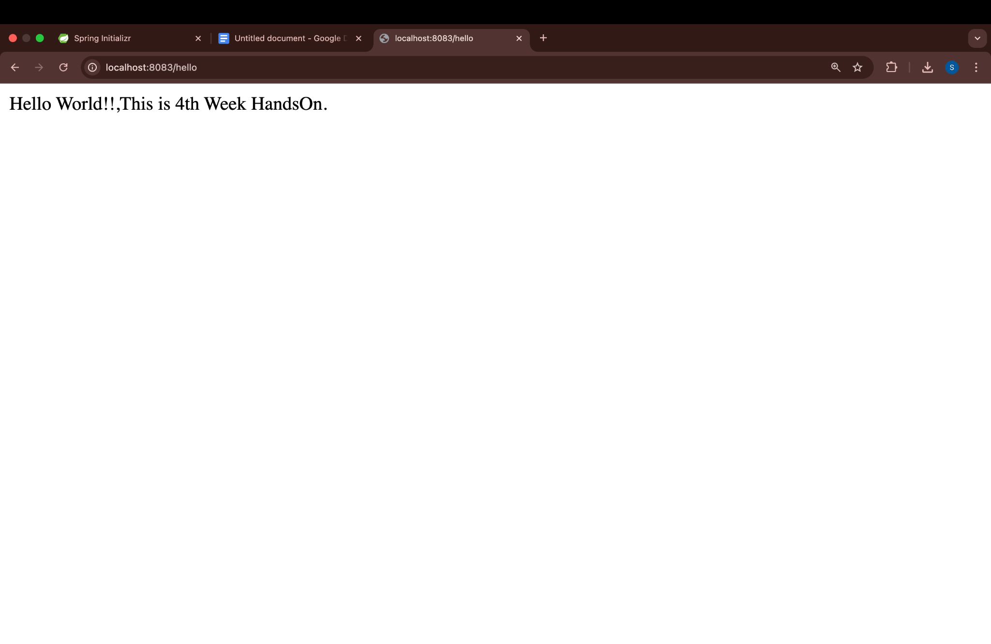

EX.3 REST - Country Web Service
package com.cognizant.springlearn;

public class Country {
private String code;
private String name;

public Country() {
// Default constructor
}
public String getCode() {
return code;
}
public void setCode(String code) {
this.code = code;
}
public String getName() {
return name;
}

public void setName(String name) {
this.name = name;
}
@Override
public String toString() {
return "Country [code=" + code + ", name=" + name + "]";
}
}

<?xml version="1.0" encoding="UTF-8"?>
<beans xmlns="http://www.springframework.org/schema/beans"
xmlns:xsi="http://www.w3.org/2001/XMLSchema-instance"
xsi:schemaLocation="http://www.springframework.org/schema/beans
https://www.springframework.org/schema/beans/spring-beans.xsd">

<bean id="country" class="com.cognizant.springlearn.Country">
<property name="code" value="IN"/>
<property name="name" value="India"/>
</bean>

</beans>

package com.cognizant.springlearn.controller;

import com.cognizant.springlearn.Country;
import org.slf4j.Logger;
import org.slf4j.LoggerFactory;
import org.springframework.web.bind.annotation.RequestMapping;
import org.springframework.web.bind.annotation.RestController;
import org.springframework.context.ApplicationContext;
import org.springframework.context.support.ClassPathXmlApplicationContext;

@RestController
public class CountryController {

private static final Logger LOGGER = LoggerFactory.getLogger(CountryController.class);

@RequestMapping("/country")
public Country getCountryIndia() {
LOGGER.info("START");
ApplicationContext context = new ClassPathXmlApplicationContext("country.xml");
Country country = context.getBean("country", Country.class);
LOGGER.info("END");
return country;
}
}

Output:

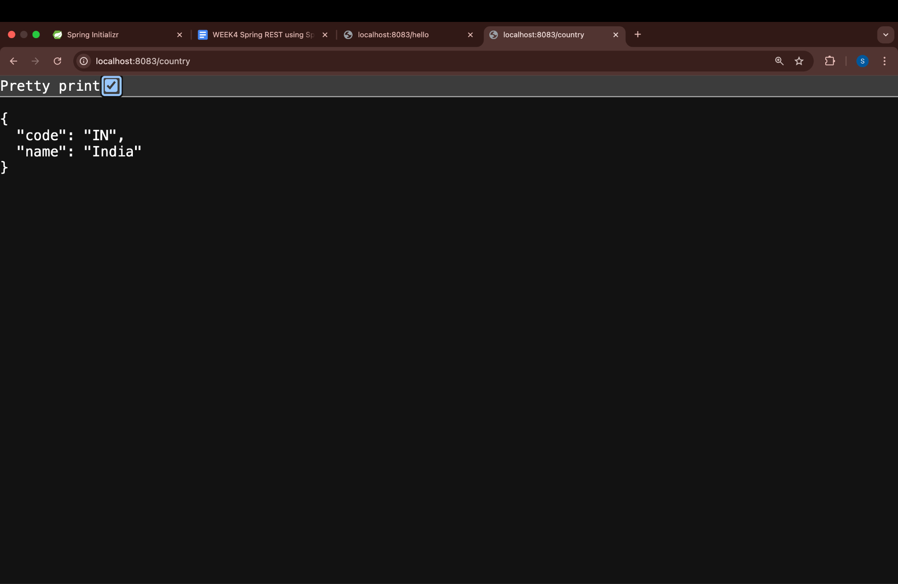

EX.4 REST - Get country based on country code
<?xml version="1.0" encoding="UTF-8"?>
<beans xmlns="http://www.springframework.org/schema/beans"
xmlns:xsi="http://www.w3.org/2001/XMLSchema-instance"
xsi:schemaLocation="http://www.springframework.org/schema/beans
https://www.springframework.org/schema/beans/spring-beans.xsd">

<bean id="in" class="com.cognizant.springlearn.Country">
<property name="code" value="IN"/>
<property name="name" value="India"/>
</bean>

<bean id="us" class="com.cognizant.springlearn.Country">
<property name="code" value="US"/>
<property name="name" value="United States"/>
</bean>

<bean id="jp" class="com.cognizant.springlearn.Country">
<property name="code" value="JP"/>
<property name="name" value="Japan"/>
</bean>

<bean id="de" class="com.cognizant.springlearn.Country">
<property name="code" value="DE"/>
<property name="name" value="Germany"/>
</bean>

<bean id="countryList" class="java.util.ArrayList">
<constructor-arg>
<list>
<ref bean="in"/>
<ref bean="us"/>
<ref bean="jp"/>
<ref bean="de"/>
</list>
</constructor-arg>
</bean>
</beans>

package com.cognizant.springlearn.controller;
import com.cognizant.springlearn.Country;
import com.cognizant.springlearn.service.CountryService;
import org.slf4j.Logger;
import org.slf4j.LoggerFactory;
import org.springframework.beans.factory.annotation.Autowired;
import org.springframework.web.bind.annotation.*;

@RestController
public class CountryController {
private static final Logger LOGGER = LoggerFactory.getLogger(CountryController.class);

@Autowired
private CountryService countryService;
@GetMapping("/countries/{code}")
public Country getCountry(@PathVariable String code) {
LOGGER.info("START");
Country country = countryService.getCountry(code);
LOGGER.info("END");
return country;
}
}
OUTPUT:

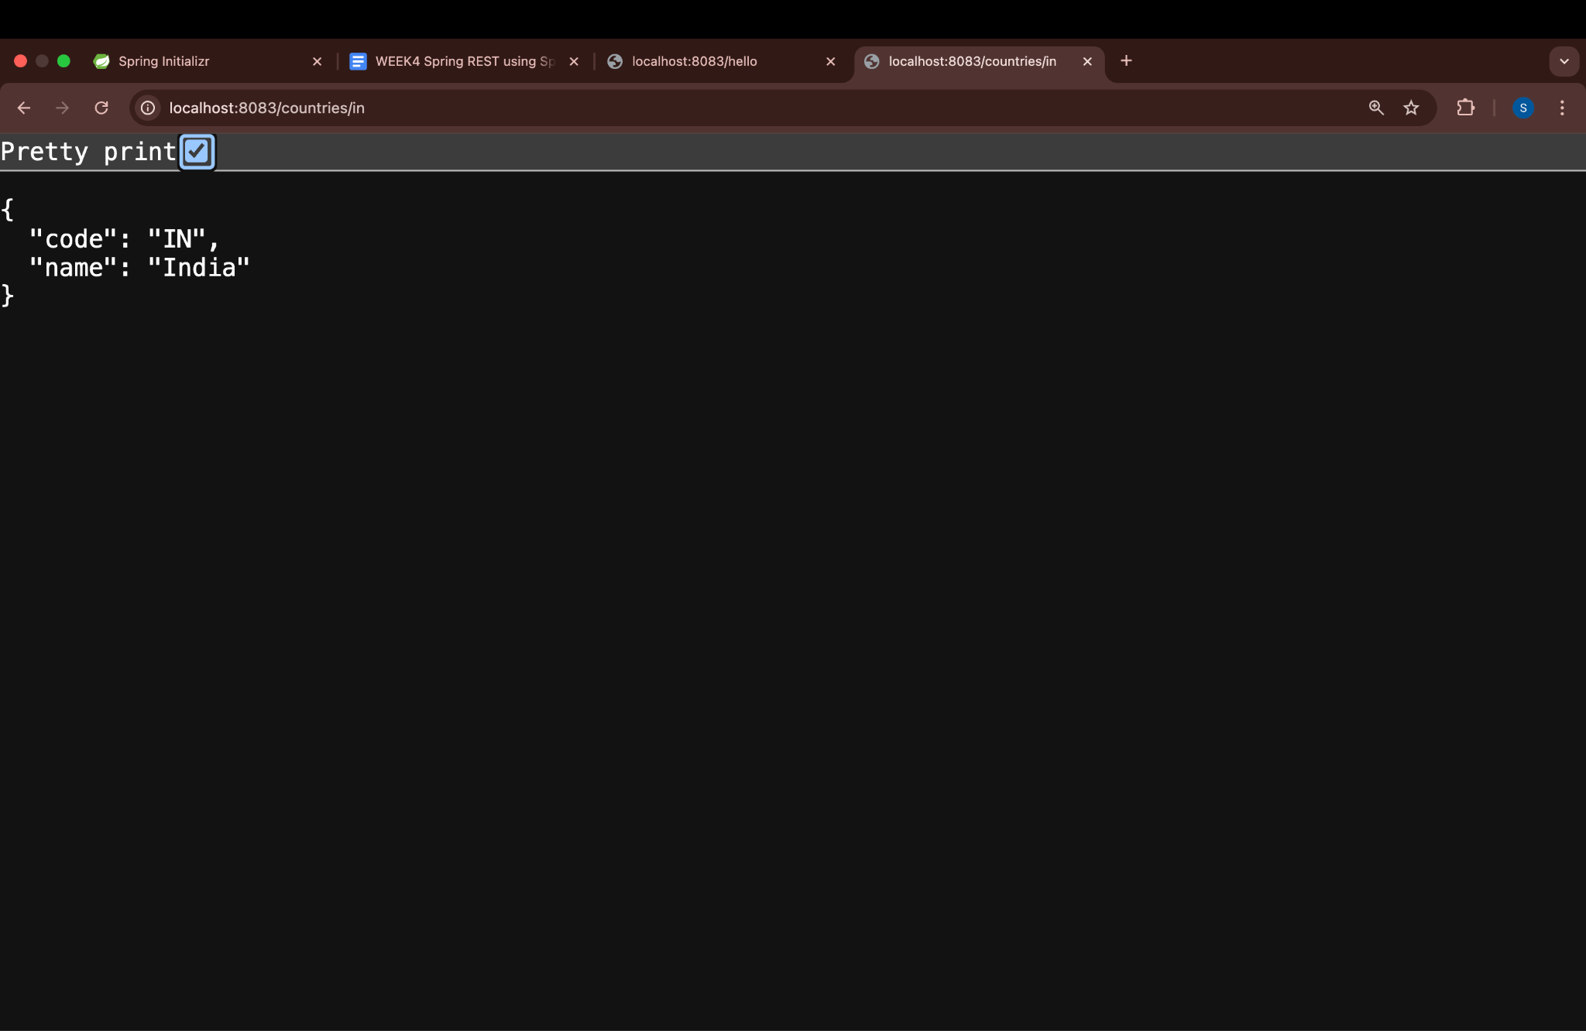

EX.5 Create authentication service that returns JWT
<dependencies>
<!-- Spring Web -->
<dependency>
<groupId>org.springframework.boot</groupId>
<artifactId>spring-boot-starter-web</artifactId>
</dependency>
<dependency>
<groupId>org.springframework.boot</groupId>
<artifactId>spring-boot-starter-security</artifactId>
</dependency>
<dependency>
<groupId>io.jsonwebtoken</groupId>
<artifactId>jjwt</artifactId>
<version>0.9.1</version>
</dependency>

<dependency>
<groupId>jakarta.xml.bind</groupId>
<artifactId>jakarta.xml.bind-api</artifactId>
<version>3.0.1</version>
</dependency>
<dependency>
<groupId>org.glassfish.jaxb</groupId>
<artifactId>jaxb-runtime</artifactId>
<version>3.0.2</version>
</dependency>
</dependencies>
package com.cognizant.springlearn.util;

import io.jsonwebtoken.Jwts;
import io.jsonwebtoken.SignatureAlgorithm;
import org.springframework.stereotype.Component;

import java.util.Date;
@Component
public class JwtUtil {
private String secretKey = "secret"; // Use env/config in real apps

public String generateToken(String username) {
return Jwts.builder()
.setSubject(username)
.setIssuedAt(new Date(System.currentTimeMillis()))
.setExpiration(new Date(System.currentTimeMillis() + 600000)) // 10 mins
.signWith(SignatureAlgorithm.HS256, secretKey)
.compact();
}
}

package com.cognizant.springlearn.controller;

import com.cognizant.springlearn.util.JwtUtil;
import org.springframework.web.bind.annotation.GetMapping;
import org.springframework.web.bind.annotation.RestController;

import javax.servlet.http.HttpServletRequest;
import java.util.Base64;

@RestController
public class AuthenticationController {
private final JwtUtil jwtUtil;
public AuthenticationController(JwtUtil jwtUtil) {
this.jwtUtil = jwtUtil;
}

@GetMapping("/authenticate")
public String authenticate(HttpServletRequest request) {
String authHeader = request.getHeader("Authorization");

if (authHeader != null && authHeader.startsWith("Basic ")) {
String base64Credentials = authHeader.substring("Basic ".length());
byte[] credDecoded = Base64.getDecoder().decode(base64Credentials);
String credentials = new String(credDecoded);
String[] values = credentials.split(":", 2);

String username = values[0]; // For example: user
String password = values[1]; // For example: pwd
if ("user".equals(username) && "pwd".equals(password)) {
String token = jwtUtil.generateToken(username);
return "{\"token\":\"" + token + "\"}";
}
}
throw new RuntimeException("Invalid Credentials");
}
}

package com.cognizant.springlearn.config;
import org.springframework.context.annotation.Bean;
import org.springframework.context.annotation.Configuration;
import org.springframework.security.config.annotation.web.builders.HttpSecurity;
import org.springframework.security.web.SecurityFilterChain;
@Configuration
public class SecurityConfig {
@Bean
public SecurityFilterChain filterChain(HttpSecurity http) throws Exception {
http
.csrf().disable()
.authorizeHttpRequests(auth -> auth
.anyRequest().authenticated()
)
.httpBasic(); // Enables Basic Auth
return http.build();
}
}

Output:

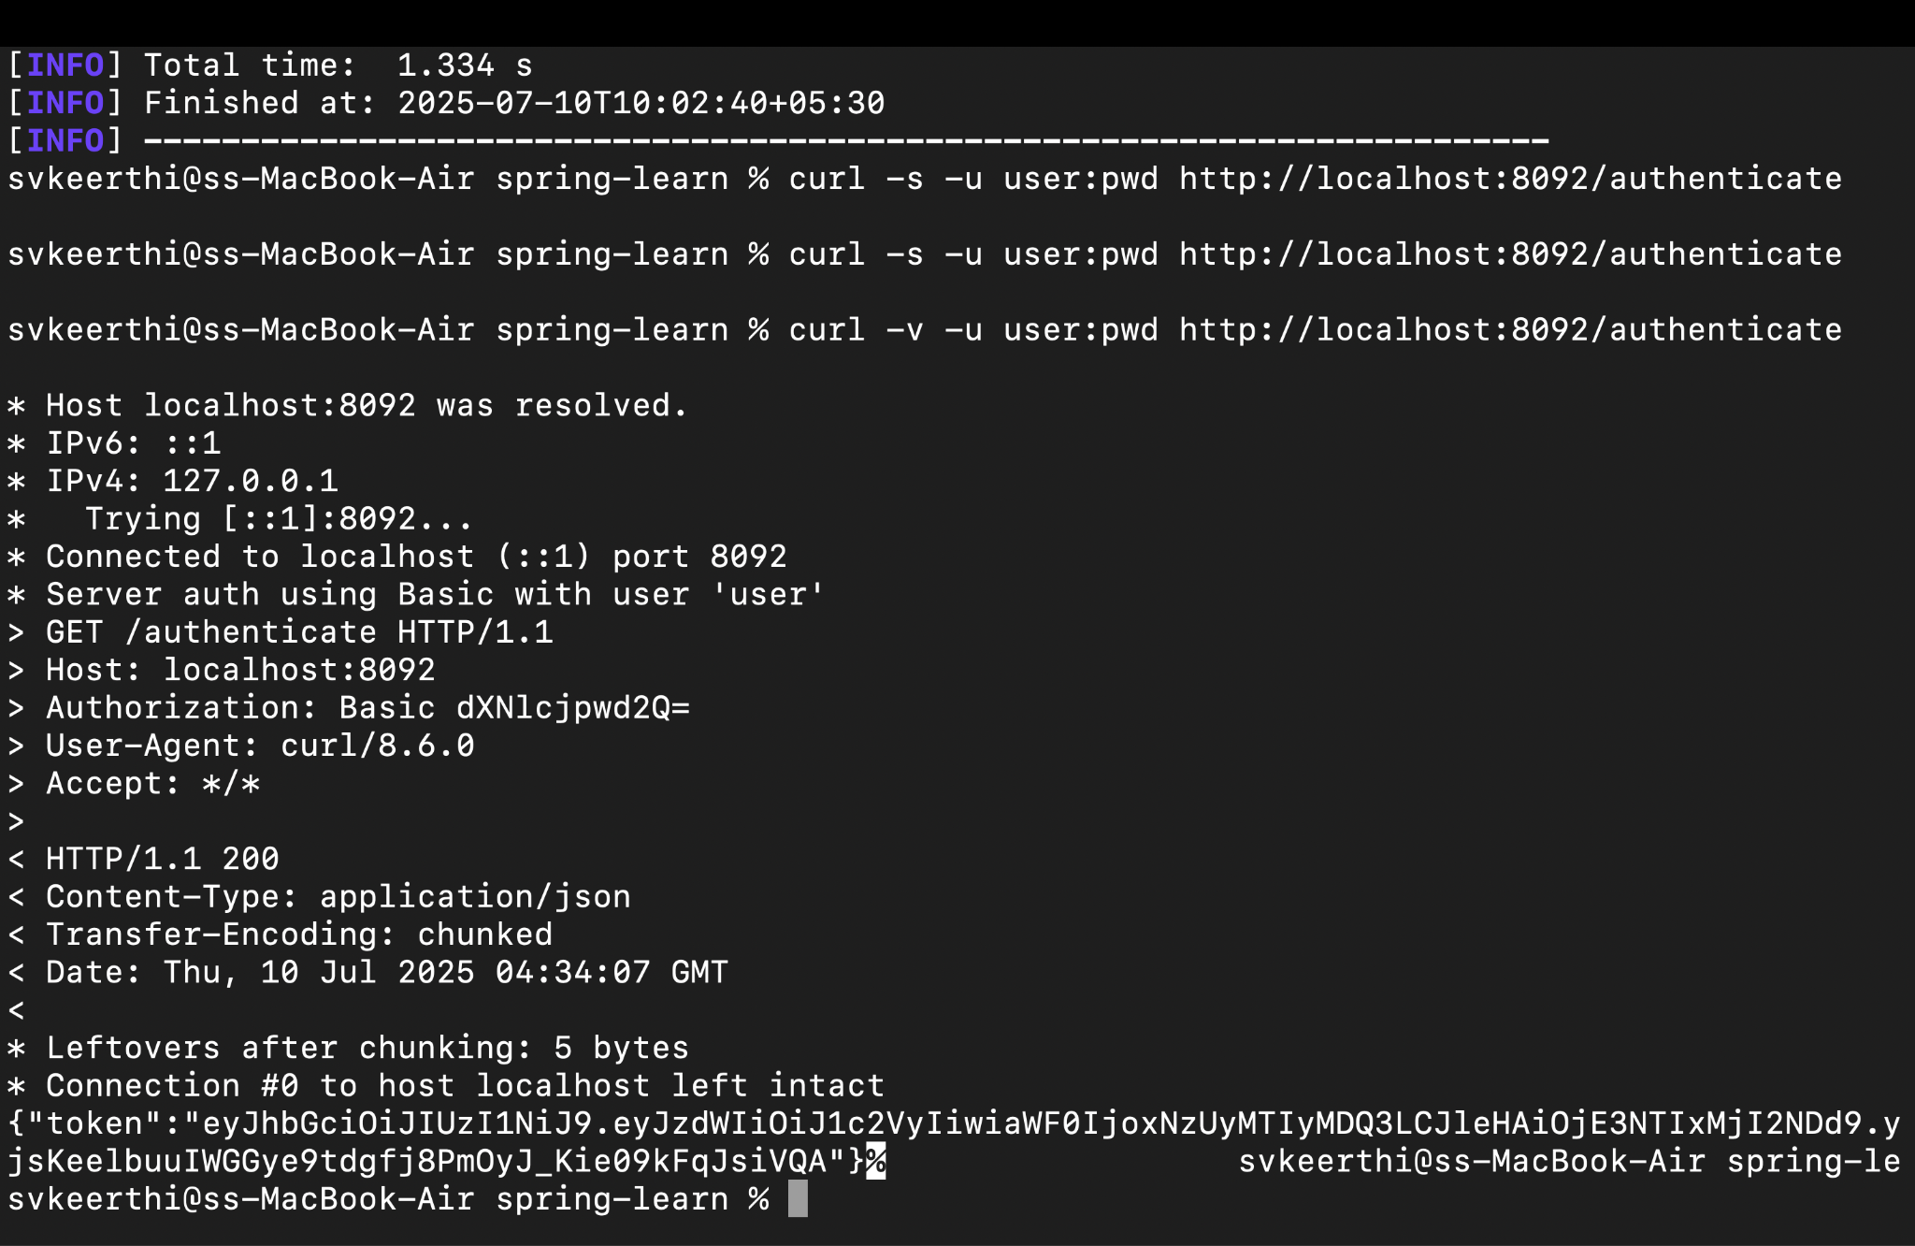

Spring REST HandsOn-Additional Mandatory
Ex.1 Display Employee List and Edit Employee form using RESTful Web Service
<?xml version="1.0" encoding="UTF-8"?>
<beans xmlns="http://www.springframework.org/schema/beans"
xmlns:xsi="http://www.w3.org/2001/XMLSchema-instance"
xsi:schemaLocation="http://www.springframework.org/schema/beans
http://www.springframework.org/schema/beans/spring-beans.xsd">

<bean id="java" class="com.example.demo.model.Skill">
<property name="id" value="1"/>
<property name="name" value="Java"/>
</bean>
<bean id="springBoot" class="com.example.demo.model.Skill">
<property name="id" value="2"/>
<property name="name" value="Spring Boot"/>
</bean>
<bean id="communication" class="com.example.demo.model.Skill">
<property name="id" value="3"/>
<property name="name" value="Communication"/>
</bean>
<bean id="recruitment" class="com.example.demo.model.Skill">
<property name="id" value="4"/>
<property name="name" value="Recruitment"/>
</bean>
<bean id="itDept" class="com.example.demo.model.Department">
<property name="id" value="1"/>
<property name="name" value="IT"/>
</bean>
<bean id="hrDept" class="com.example.demo.model.Department">
<property name="id" value="2"/>
<property name="name" value="HR"/>
</bean>
<bean id="employee1" class="com.example.demo.model.Employee">
<property name="id" value="1"/>
<property name="name" value="Alice"/>
<property name="salary" value="70000"/>
<property name="department" ref="itDept"/>
<property name="skills">
<list>
<ref bean="java"/>
<ref bean="springBoot"/>
</list>
</property>
</bean>
<bean id="employee2" class="com.example.demo.model.Employee">
<property name="id" value="2"/>
<property name="name" value="Bob"/>
<property name="salary" value="60000"/>
<property name="department" ref="hrDept"/>
<property name="skills">
<list>
<ref bean="communication"/>
<ref bean="recruitment"/>
</list>
</property>
</bean>
<!-- List of Employees -->
<bean id="employeeList" class="java.util.ArrayList">
<constructor-arg>
<list>
<ref bean="employee1"/>
<ref bean="employee2"/>
</list>
</constructor-arg>
</bean>
</beans>
@SpringBootApplication
@ImportResource("classpath:employee.xml")
public class DemoApplication {
public static void main(String[] args) {
SpringApplication.run(DemoApplication.class, args);
}
}

@Repository
public class EmployeeDao {
public static List<Employee> EMPLOYEE_LIST;
@Autowired
public EmployeeDao(@Value("classpath:employee.xml") Resource resource) throws Exception {
ApplicationContext context = new FileSystemXmlApplicationContext("src/main/resources/employee.xml");
EMPLOYEE_LIST = (List<Employee>) context.getBean("employeeList");
}

public List<Employee> getAllEmployees() {
return EMPLOYEE_LIST;
}

public Employee getEmployeeById(int id) {
return EMPLOYEE_LIST.stream().filter(e -> e.getId() == id).findFirst().orElse(null);
}
}

@Service
public class EmployeeService {
@Autowired
private EmployeeDao employeeDao;
@Transactional
public List<Employee> getAllEmployees() {
return employeeDao.getAllEmployees();
}
public Employee getEmployeeById(int id) {
return employeeDao.getEmployeeById(id);
}
}

@RestController
@RequestMapping("/employees")
public class EmployeeController {
@Autowired
private EmployeeService employeeService;
@GetMapping
public List<Employee> getAllEmployees() {
return employeeService.getAllEmployees();
}
@GetMapping("/{id}")
public Employee getEmployeeById(@PathVariable int id) {
return employeeService.getEmployeeById(id);
}
}

@Repository
public class DepartmentDao {
public static List<Department> DEPARTMENT_LIST;
@Autowired
public DepartmentDao() {
DEPARTMENT_LIST = new ArrayList<>();
DEPARTMENT_LIST.add(new Department(1, "IT"));
DEPARTMENT_LIST.add(new Department(2, "HR"));
}
public List<Department> getAllDepartments() {
return DEPARTMENT_LIST;
}
}
public class Employee {
private int id;
private String name;
private double salary;
private Department department;
private List<Skill> skills;
}
public class Department {
private int id;
private String name;

public Department() {}
public Department(int id, String name) {
this.id = id;
this.name = name;
}
}
public class Skill {
private int id;
private String name;
}
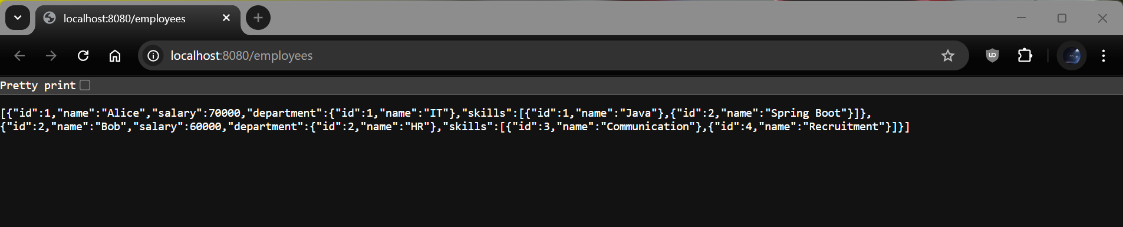
Output:

Ex.2 Create static employee list data using spring xml configuration
<?xml version="1.0" encoding="UTF-8"?>
<beans xmlns="http://www.springframework.org/schema/beans"
xmlns:xsi="http://www.w3.org/2001/XMLSchema-instance"
xsi:schemaLocation="http://www.springframework.org/schema/beans
http://www.springframework.org/schema/beans/spring-beans.xsd">

<bean id="java" class="com.example.demo.model.Skill">
<property name="id" value="1"/>
<property name="name" value="Java"/>
</bean>
<bean id="springBoot" class="com.example.demo.model.Skill">
<property name="id" value="2"/>
<property name="name" value="Spring Boot"/>
</bean>
<bean id="communication" class="com.example.demo.model.Skill">
<property name="id" value="3"/>
<property name="name" value="Communication"/>
</bean>
<bean id="recruitment" class="com.example.demo.model.Skill">
<property name="id" value="4"/>
<property name="name" value="Recruitment"/>
</bean>
<bean id="itDept" class="com.example.demo.model.Department">
<property name="id" value="1"/>
<property name="name" value="IT"/>
</bean>
<bean id="hrDept" class="com.example.demo.model.Department">
<property name="id" value="2"/>
<property name="name" value="HR"/>
</bean>
<bean id="employee1" class="com.example.demo.model.Employee">
<property name="id" value="1"/>
<property name="name" value="Alice"/>
<property name="salary" value="70000"/>
<property name="department" ref="itDept"/>
<property name="skills">
<list>
<ref bean="java"/>
<ref bean="springBoot"/>
</list>
</property>
</bean>

<bean id="employee2" class="com.example.demo.model.Employee">
<property name="id" value="2"/>
<property name="name" value="Bob"/>
<property name="salary" value="60000"/>
<property name="department" ref="hrDept"/>
<property name="skills">
<list>
<ref bean="communication"/>
<ref bean="recruitment"/>
</list>
</property>
</bean>

<!-- Static Employee List -->
<bean id="employeeList" class="java.util.ArrayList">
<constructor-arg>
<list>
<ref bean="employee1"/>
<ref bean="employee2"/>
</list>
</constructor-arg>
</bean>

</beans>

@Repository
public class EmployeeDao {
public static List<Employee> EMPLOYEE_LIST;
@Autowired
public EmployeeDao(@Value("classpath:employee.xml") Resource resource) throws Exception {
ApplicationContext context = new FileSystemXmlApplicationContext("src/main/resources/employee.xml");
EMPLOYEE_LIST = (List<Employee>) context.getBean("employeeList");
}

public List<Employee> getAllEmployees() {
return EMPLOYEE_LIST;
}
}
@SpringBootApplication
@ImportResource("classpath:employee.xml")
public class DemoApplication {
public static void main(String[] args) {
SpringApplication.run(DemoApplication.class, args);
}
}

Output:
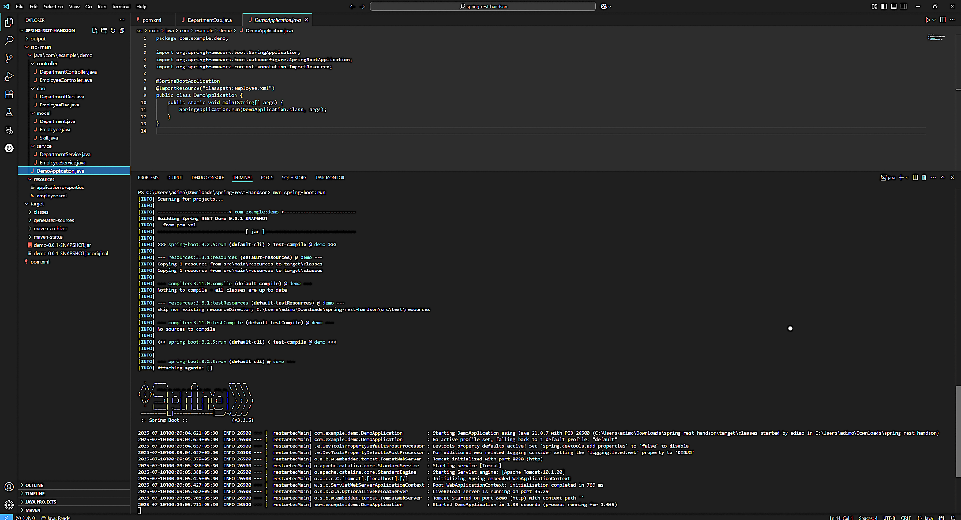

Ex.3 Create REST service to gets all employees
@Repository
public class EmployeeDao {

public static List<Employee> EMPLOYEE_LIST;

@Autowired
public EmployeeDao(@Value("classpath:employee.xml") Resource resource) throws Exception {
ApplicationContext context = new FileSystemXmlApplicationContext("src/main/resources/employee.xml");
EMPLOYEE_LIST = (List<Employee>) context.getBean("employeeList");
}
public List<Employee> getAllEmployees() {
return EMPLOYEE_LIST;
}
public Employee getEmployeeById(int id) {
return EMPLOYEE_LIST.stream().filter(e -> e.getId() == id).findFirst().orElse(null);
}
}

@Service
public class EmployeeService {
@Autowired
private EmployeeDao employeeDao;
@Transactional
public List<Employee> getAllEmployees() {
return employeeDao.getAllEmployees();
}

public Employee getEmployeeById(int id) {
return employeeDao.getEmployeeById(id);
}
}

@RestController
@RequestMapping("/employees")
public class EmployeeController {

@Autowired
private EmployeeService employeeService;
@GetMapping
public List<Employee> getAllEmployees() {
return employeeService.getAllEmployees();
}

@GetMapping("/{id}")
public Employee getEmployeeById(@PathVariable int id) {
return employeeService.getEmployeeById(id);
}
}

Output:
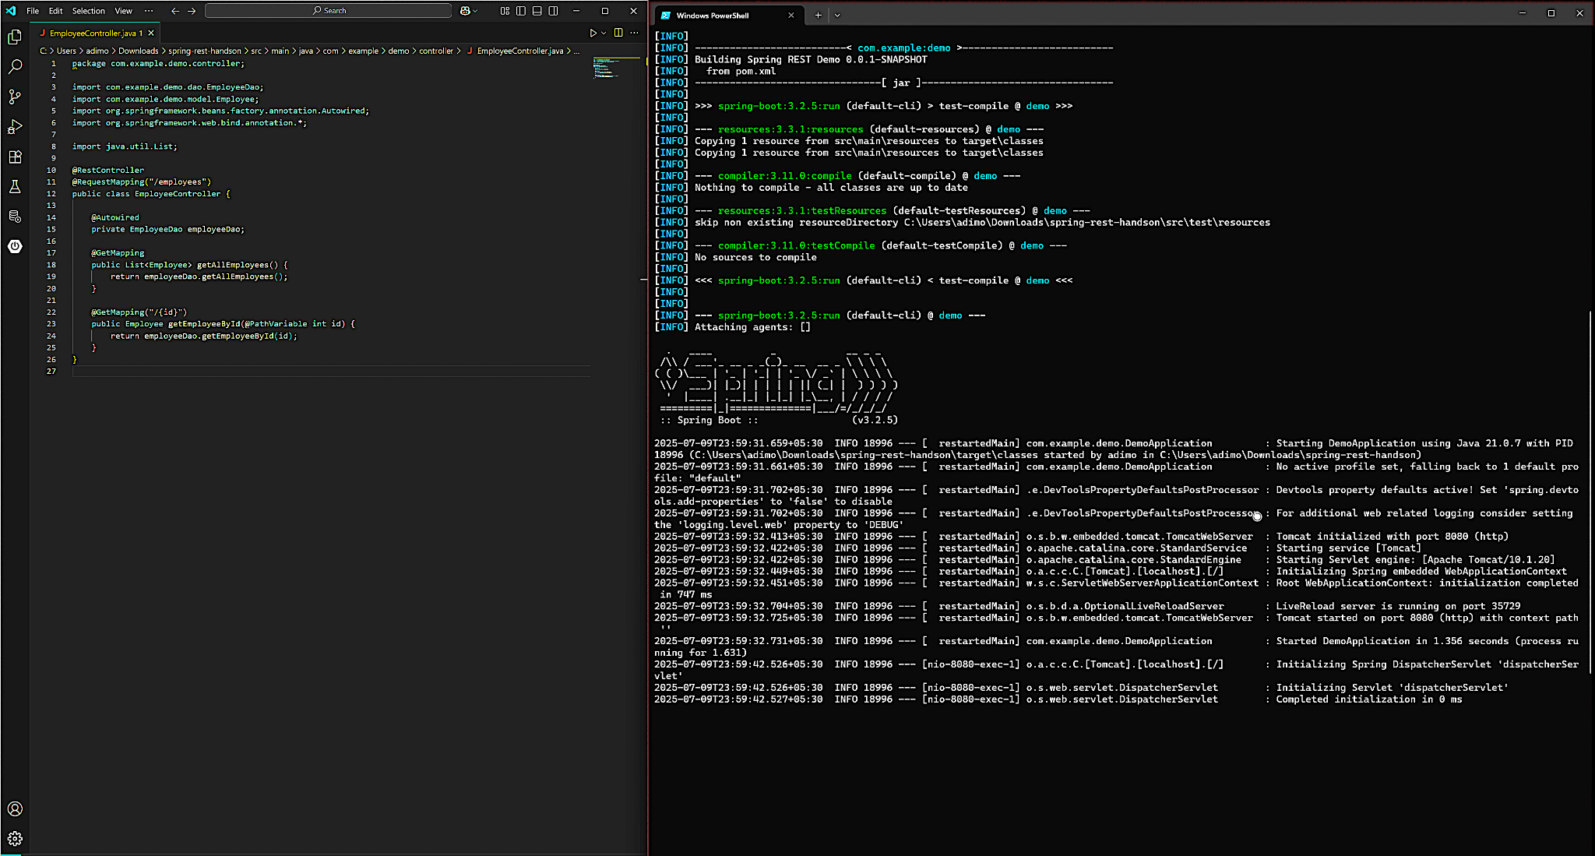

Ex.4 Create REST service for department

<bean id="itDept" class="com.example.demo.model.Department">
<property name="id" value="1"/>
<property name="name" value="IT"/>
</bean>

<bean id="hrDept" class="com.example.demo.model.Department">
<property name="id" value="2"/>
<property name="name" value="HR"/>
</bean>
<bean id="departmentList" class="java.util.ArrayList">
<constructor-arg>
<list>
<ref bean="itDept"/>
<ref bean="hrDept"/>
</list>
</constructor-arg>
</bean>
@Repository
public class DepartmentDao {

public static List<Department> DEPARTMENT_LIST;

@Autowired
public DepartmentDao() {
ApplicationContext context = new FileSystemXmlApplicationContext("src/main/resources/employee.xml");
DEPARTMENT_LIST = (List<Department>) context.getBean("departmentList");
}

public List<Department> getAllDepartments() {
return DEPARTMENT_LIST;
}
}
@Service
public class DepartmentService {

@Autowired
private DepartmentDao departmentDao;

@Transactional
public List<Department> getAllDepartments() {
return departmentDao.getAllDepartments();
}
}

@RestController
@RequestMapping("/departments")
public class DepartmentController {

@Autowired
private DepartmentService departmentService;
@GetMapping
public List<Department> getAllDepartments() {
return departmentService.getAllDepartments();
}
}

Output:

